Executive Summary
Today, customer Teams meetings leave no trace in CRM — transcripts are lost, meetings aren't linked to records, and managers can't see what was discussed. This solution fixes that automatically: sellers are prompted in Teams to link every customer meeting to its lead or opportunity, Dynamics 365 conversation intelligence records, transcribes, and publishes the conversation with AI insights directly onto that record, and document attachments sync to SharePoint. The result is complete conversation history on every deal and pipeline-wide visibility for leadership. Requires Sales Premium licensing; piloted and measured within four weeks.
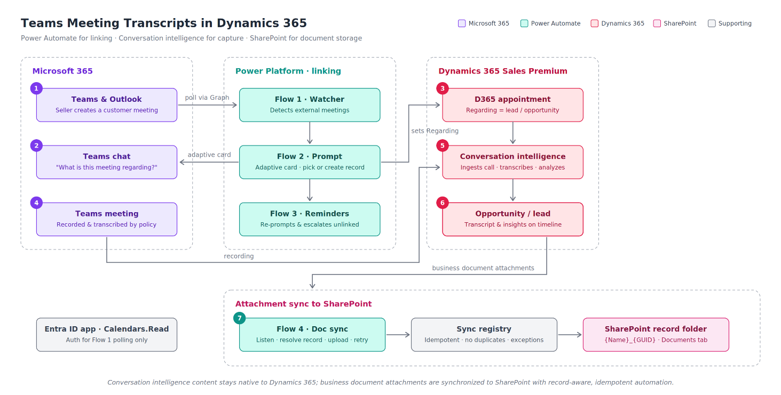

How it works
- Flow 1 · Watcher — polls sellers' calendars via Microsoft Graph every 15 minutes and detects new meetings with external attendees.
- Flow 2 · Prompt — sends the organizer an adaptive card in Teams: pick the related lead/opportunity (pre-ranked from attendee emails) or create a new lead on the spot.
- Linking — The selection sets the Regarding field on the server-side-synced D365 appointment — Microsoft's native meeting-to-record linkage.
- Flow 3 · Reminders — re-prompts unlinked meetings and escalates to managers after the meeting ends, making compliance visible.
- Capture — The meeting is recorded and transcribed per Teams meeting policy.
- Attach — Conversation intelligence ingests the call and publishes the transcript, playback, sentiment, keywords, and action items to the linked record's timeline.
- SharePoint file sync

Prerequisites
- Dynamics 365 Sales Premium (or conversation intelligence add-on) for sellers in scope
- Exchange server-side sync enabled (Outlook/Teams meetings materialize as D365 appointments)
- Teams meeting policies enforcing recording and transcription for customer calls
- Conversation intelligence configured in Sales app settings (Teams call data connected)
- Service account with Power Automate Premium; Entra ID app with Calendars. Read (admin consented)

Component detail
Component | Summary
Flow 1 · Watcher | Polls in-scope seller calendars every 15 minutes, detects external Teams meetings, skips already-linked appointments, and calls the prompt flow using configuration-driven seller and domain lists.
Flow 2 · Prompt | Ranks likely lead/opportunities from attendee emails, sends a Teams adaptive card, and writes the selected record to the synced D365 Appointment’s Regarding field.
Flow 3 · Reminders | Re-prompts unlinked meetings before and after the meeting, then notify managers after 48 hours so linkage compliance is visible.
Conversation intelligence | Uses Teams meeting data to publish transcript, playback, sentiment, keywords, and action items to the record resolved through the Regarding link.
Security & auth | Uses an admin-consented Entra ID app for calendar reads and a Power Automate service account with least-privilege D365 access.

Delivery plan
Phase | Summary
1 · Foundation (wk 1) | Confirm licensing, server-side sync, Teams recording/transcription policy, Entra app, service account, and conversation intelligence setup.
2 · Build (wk 2) | Create configuration, build Flows 1–3, validate Regarding updates, and test adaptive card paths with pilot sellers.
3 · Pilot (wk 3–4) | Run with one team, measure linkage and transcript arrival, tune ranking/reminders, and confirm compliance requirements.
4 · Rollout | Expand scope, publish seller guidance, and add manager dashboards for linkage and conversation intelligence visibility.

